1. Introduction
1.1 Purpose of this Document
- This System Design Document (SDD) specifies the architecture, Components, interfaces, and other design considerations for FarmBotika, an end-to-end smart-agriculture platform. It bridges the gap between requirements and implementation, ensuring that developers, testers, and stakeholders share a clear, common blueprint.
1.2 Scope of the System
FarmBotika will enable small-scale farmers to:
- Monitor field conditions, example- Soil moisture, temperature, pest detection- via IoT sensors.
- Access AI-Powered recommendations and chat-based agronomic support.
- Manage farm data, plan planting schedules, and track yields.
- Receive alerts and notifications on mobile and web interfaces.
1.3 Intended Audience
- Developers: Implement modules per design.
- Testers: Develop and execute test cases.
- DevOps/ Infrastructure Engineers: Deploy and operate the system.
- Project Managers/ Stakeholders: Review high-level architecture and risk mitigations.
1.4 Glossary
- API Gateway: Single entry point for client requests, routing to microservices.
- LLM: Large Language Model, used for agronomy Q&A.
- Celery: Distributed task queue.
- JWT: JSON Web Token, for stateless authentication.

2. System Overview and Design Philosophy
2.1 High Level Description
FarmBotika is implemented as a microservices-based web application:
- Frontend: React, Tailwind CSS, JavaScript, Mobile-responsive.
- Backend: Python, Django REST Framework services, Node JS.
- AI Service: Flask microservice hosting the LLM for agronomic advice.
- Data Pipeline: Celery + RabbitMQ for asynchronous tasks.
- Database: PostgreSQL for relational data; Firebase for IoT data; Redis for caching and Celery broker.

2.2 Design Principles
- Modularity: Each service encapsulates a distinct domain (User, Sensor, AI).
- Scalability: Stateless services behind load balancers, horizontal scaling.
- Reusability: Shared libraries for authentication, logging, error handling.
- Performance: Caching hot data in Redis; lazy loading in Frontend.
- Security: HTTP everywhere; JWT for API access; encrypted storage for sensitive data.

3. Architectural Design
3.1 Architecture Diagram
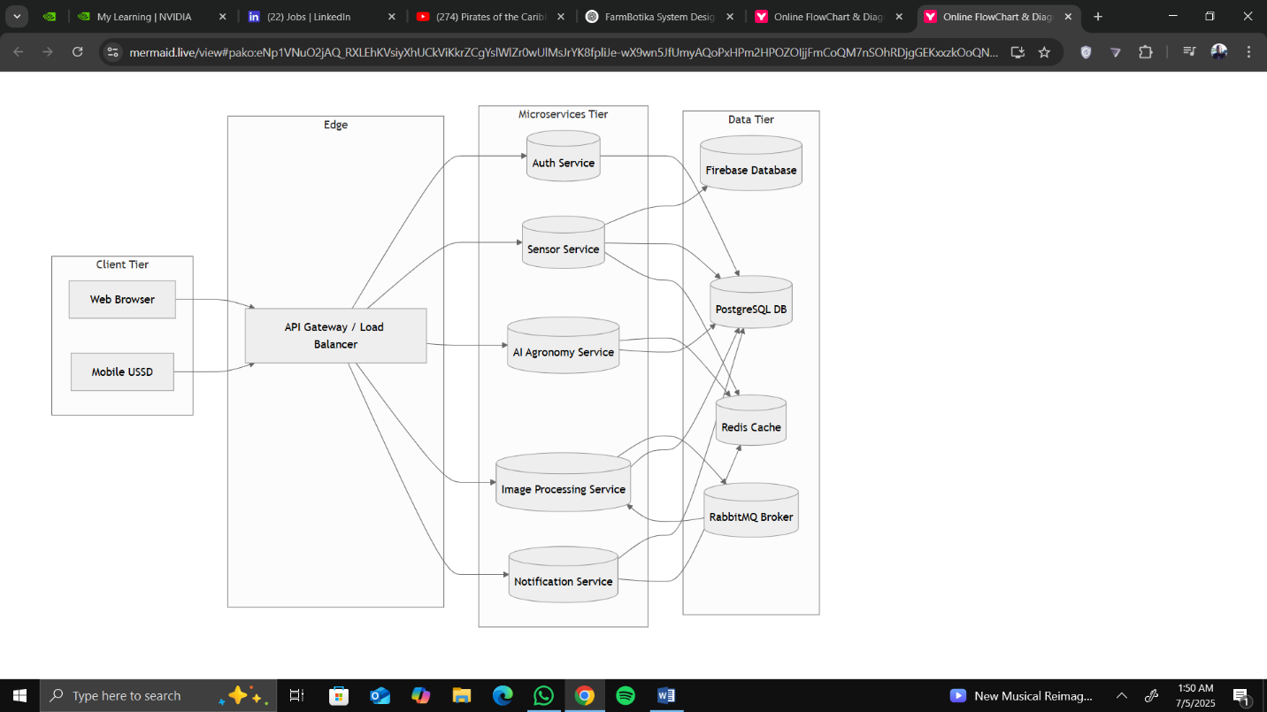
3.2 Architecture Style
- Microservices: communicating via REST and AMPQ.
- Client-Server: React frontend calls backend via API Gateway.
- Event-Driven for long-running tasks.

3.3 Component Description
Component | Description
- API Gateway | Routes requests to appropriate backend services; handles rate limiting and authentication.
- Auth Service | Manages user signup/login, role-based access (Admin, Staff, Farmer).
- Sensor Service | Ingests IoT sensor data; validation and storage.
- AI Service | Hosts LLM inference; processes user queries for agronomic advice.
- Image Service | Receives field images; runs pest detection computer-vision pipeline; stores results.
- Web Frontend | React SPA; dashboards, data entry forms, real-time charts.
- Mobile Frontend | Progressive Web App optimized for low-bandwidth mobile devices.
- Database | PostgreSQL with tables for users, farms, sensors, readings, alerts.
- Cache | Redis for session data, recent sensor readings, AI response caching.
- Message Broker | RabbitMQ for Celery tasks (e.g., image processing, bulk notifications).
- CI/CD Pipeline | GitHub Actions building, testing, and deploying containers to Docker.

4. Detailed Design

4.1 Module / Feature Descriptions

4.1.1 User Management
- Functionality: Register/login, role, role assignment, password reset.
- Inputs: username, password, email, role.
- Outputs: JWT token, user profile
- Business Rules:
  - Passwords hashed with Bcrypt.
  - Email verification required.
- Data Elements: userID, username, email, password_hash, role

4.1.2 Sensor Data Ingestion
- Functionality: Accepts sensor payloads (JSON), validates, stores readings.
- Inputs: sensor_id, timestamps, metrics (moisture, temperature).
- Outputs: HTTP 201 on success; queued alerts if thresholds crossed.
- Business Rule:
  - Reject data older than 24 hours.
- Data Elements: readingID, sensor_id, metric_type, value, timestamp.

4.1.3 AI-Powered Agronomy Chat
- Functionality: Processes farmer questions; returns LLM response.
- Inputs: user_query, context (farm_id, recent_readings).
- Outputs: text_response, confidence_score.
- Business Rule:
  - Rate-limit queries per user, example: 20/day.
- Data Elements: queryID, userID, timestamp, prompt, response, cost_metrics.

4.1.4 Notification Service
- Functionality: Sends alerts and informational messages to users, and handles message automation.
- Inputs: userID, message_body, notification_type (alert info, warning), trigger_source (Sensor, AI, Admin)
- Outputs: Push/Email/SMS alert sent to user.
- Business Rules:
  - High-Priority alerts, example: critical soil dryness, are marked as “urgent”.
  - Alerts are rate-limited per user, example: max 10/hour.
  - Users can mark alerts as read or delete them.
  - Unread alerts are highlighted in the dashboard.
- Data Elements: notification_id, userID, message, type, status, triggered_by, created_at, read_at

4.1.5 Farm Management
- Functionality: Allows users to create, update, and manage farm details (name, location, crop type).
- Inputs: name, location (GPS), size, crop_type, userID
- Outputs: new or updated farm profile, farm overview on dashboard, associated sensors and reports.
- Business Rules:
  - One user can own multiple farms.
  - Each farm must have a unique name per user.
  - Location is validated using geolocation services.
  - Users can deactivate a farm.
- Data Elements: farm_id, userID, name, location, size_in_hectares, crop_type, status, created_at, upd_at.

NB:<< Image Recognition service to be added >>

4.2 Interface Design

4.2.1 UI Mockups
- Dashboard: real-time charts of soil moisture, alerts panel.
- Chart Screen: text input, message history, quick-tips, sidebar.

4.2.2 Navigation Flow:
- Login --> Dashboard --> Farm Overview.
- Dashboard --> Chat --> View Recommendation
- Alerts --> Detail Page --> Acknowledge / Dismiss

4.2.3 API Interface Specifications
Endpoint | Method | Request Body | Response | Status Codes
/api/auth/login | POST | {email, password} | {token, user} | 200, 401
/api/sensors/{id}/readings | POST | {timestamp, metrics} | {reading_id} | 201, 400
/api/ai/query | POST | {prompt, context} | {response, confidence} | 200, 429, 500
5. Database Design
5.1 ER Diagram

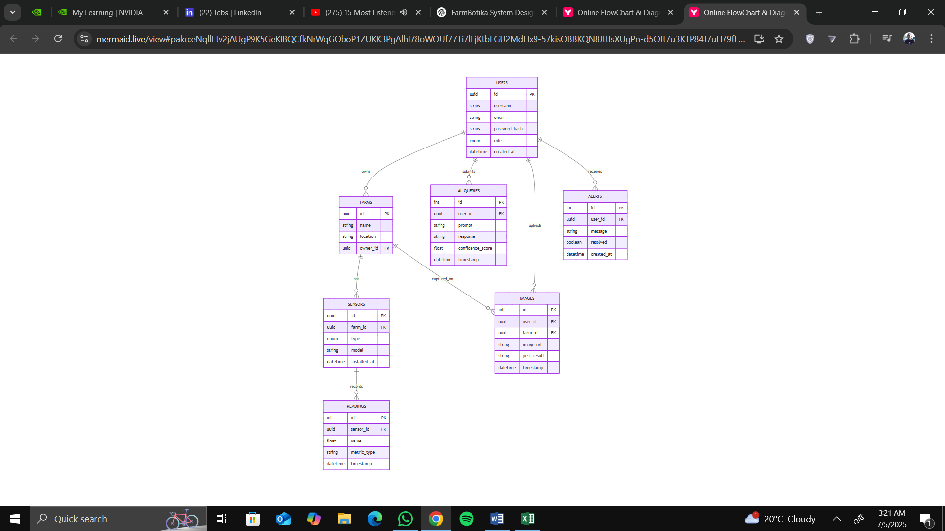

5.2 Normalization
This design follows Third Normal Form (3NF) to eliminate redundancy

5.3 Data Dictionary
Table | Field | Type | Null | Description
users | id | UUID PK | No | Unique user identifier
 | email | VARCHAR(255) | No | User email
 | password_hash | VARCHAR(255) | No | BCrypt hash
 | role | ENUM | No | admin, staff, farmer
sensors | id | UUID PK | No | Unique sensor identifier
 | farm_id | UUID FK | No | Associated farm
 | type | VARCHAR(50) | No | e.g., moisture, temperature
readings | id | SERIAL PK | No
 | sensor_id | UUID FK | No
 | value | FLOAT | No
 | timestamp | TIMESTAMP | No

6. Data Flow Diagram

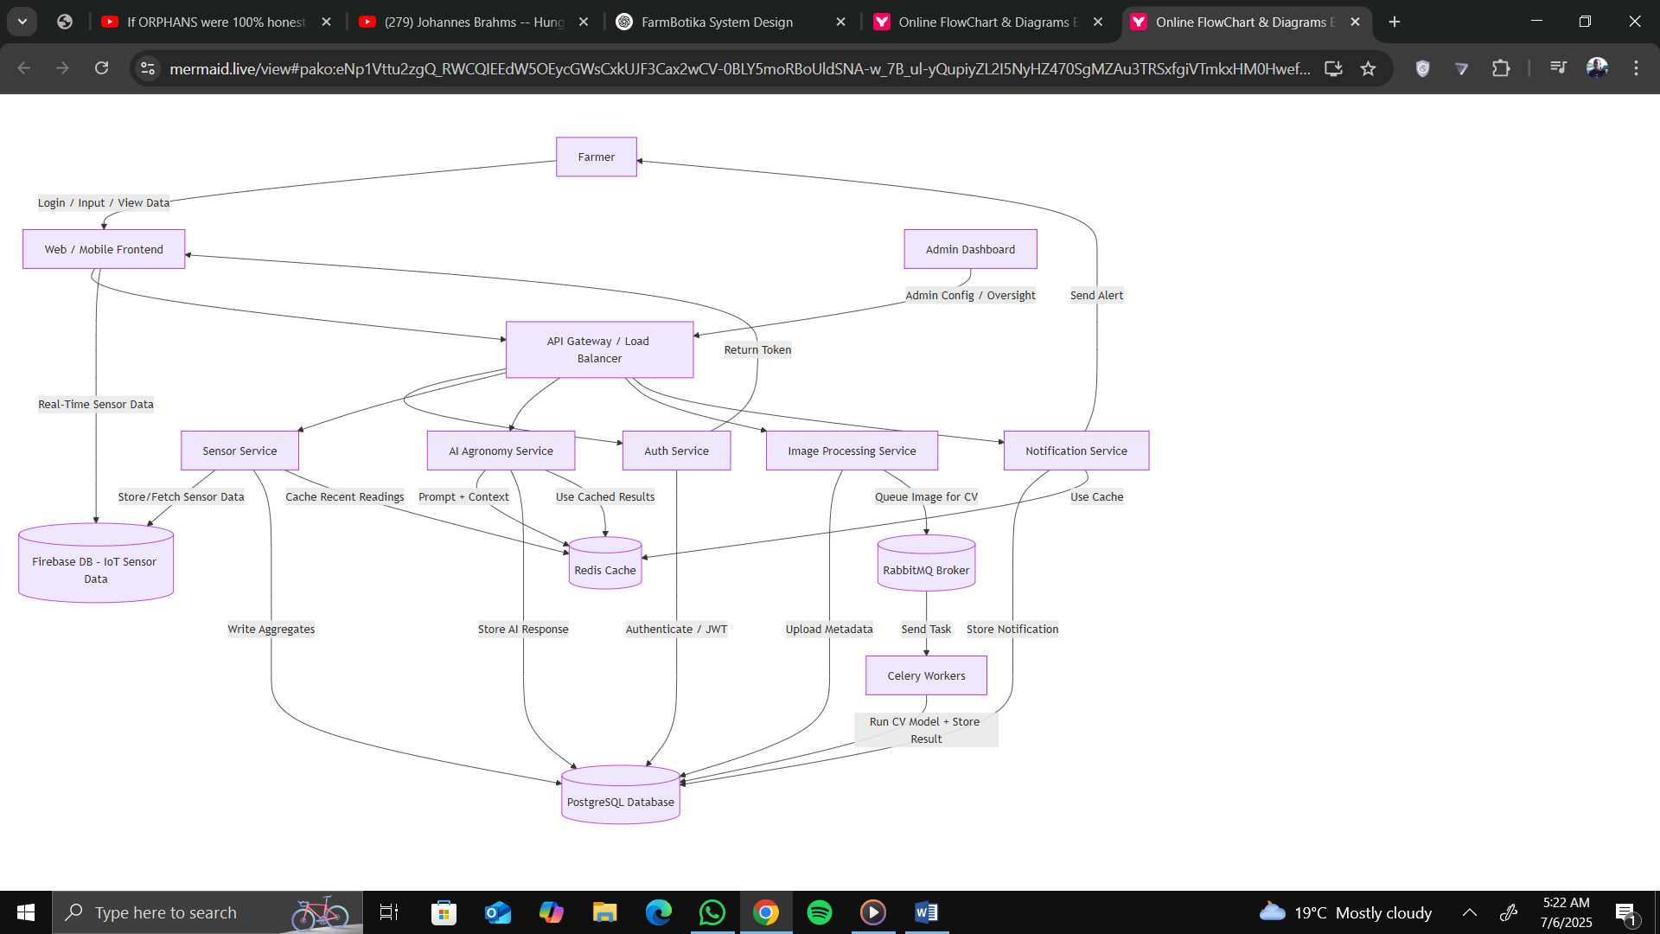

7. Non-Functional Design Considerations
(a.) Performance Optimization:
- Redis Caching for recent reading and AI Responses.
- Database indexing on sensor_id, timestamp.
(b.) Security Design:
- Authentication with JWT; token expiry in 1 hour; refresh tokens via /auth/refresh.
- HTTP enforced.
- Encryption of sensitive fields at rest.
(c.) Scalability Plans:
- Dockerized services deployed in Docker.
(d.) Availability and Fault Tolerance:
- Retry logic in Celery tasks.
(e.) Usability and Accessibility:
- Responsive design for mobile network constraints.

NB: More sections coming soon!!

